 | Course Name: Advanced Web Technology | EXPERIMENT NO. 4
 | Course Code: 20CP314P  Faculty: Komal Singh | Branch: CSE
 | Course Code: 20CP314P  Faculty: Komal Singh | Semester: VI
Submitted by: Harsh Shah
Roll no: 21BCP359

Objective: Building models with Mongoose
Create a database schema and model using mongoose and perform MongoDB queries for operations such as insert, update, and delete while also establishing a connection to the MongoDB database.

Mongoose Connection
const mongoose = require("mongoose");
mongoose
.connect("mongodb://localhost/mydb")
.then(() => console.log("Connected to MongoDB successfully!"))
.catch((error) => console.error("Error connecting to MongoDB", error));
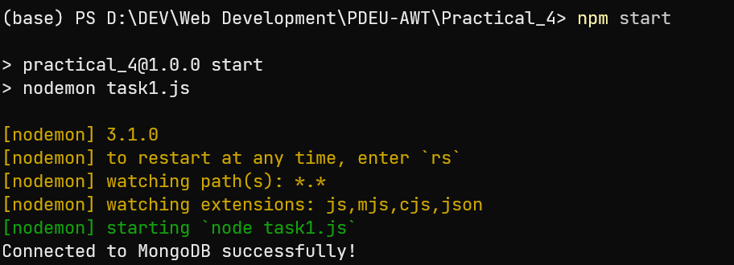

Database Schema
const schema = new mongoose.Schema({
name: {
type: String,
required: true,
},
email: {
type: String,
required: true,
unique: true,
},
age: {
type: Number,
default: 0,
},
deregistered: {
type: Date,
default: Date.now,
},
});
const obj = mongoose.model("subsription", schema);

Insert Operation
const newobj = new obj({
name: "Harsh Shah",
email: "harsh.sce21@sot.pdpu.ac.in",
age: 20,
});
newobj
.save()
.then((kri) => console.log("User created:", kri))
.catch((err) => console.error(err));
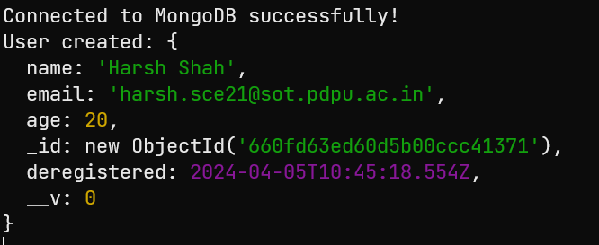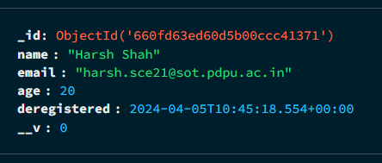

- Insert One
const Newuser = new obj({ name: "krish", email: "ky@gmail.com", age: 20 });
obj.collection
.insertOne(Newuser)
.then((data) => {
console.log(data);
})
.catch((err) => {
console.log(err);
});
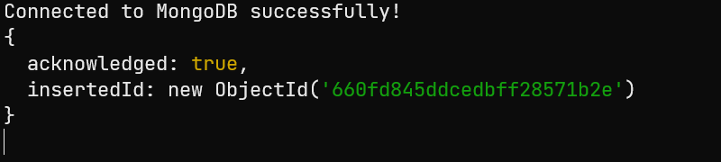
- Insert Many
const Newuser = new obj({ name: "krishna", email: "ku@gmail.com", age: 20 });
const Newuser1 = new obj({ name: "kriti", email: "kr@gmail.com", age: 21 });

obj.collection
.insertMany([Newuser, Newuser1])
.then((data) => {
console.log(data);
})
.catch((err) => {
console.log(err);
});
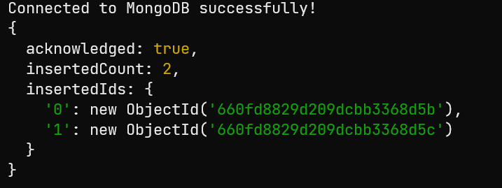

Update Operation
- Update One
obj.updateOne({ name: "krishna" }, { $set: { name: "madhav" } })
.then((docs) => {
if (docs) {
console.log(docs);
} else {
console.log("no such user exist");
}
})
.catch((err) => {
console.log(err);
});
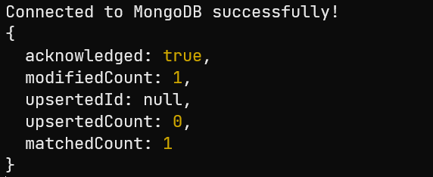
- Update Many
obj.updateMany({age: 20},{$set:{ age: 15}})
.then((docs)=>{
if(docs) {
console.log(docs);
} else {
console.log("no such user exist");
}
}).catch((err)=>{
console.log(err);
});
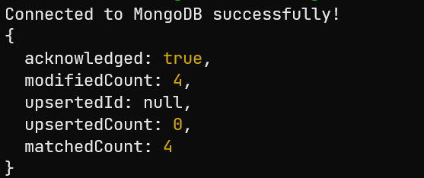

Find/Search Operation
- Find without query
obj.find({})
.then((doc) => {
console.log(doc);
})
.catch((err) => {
console.log(err);
});
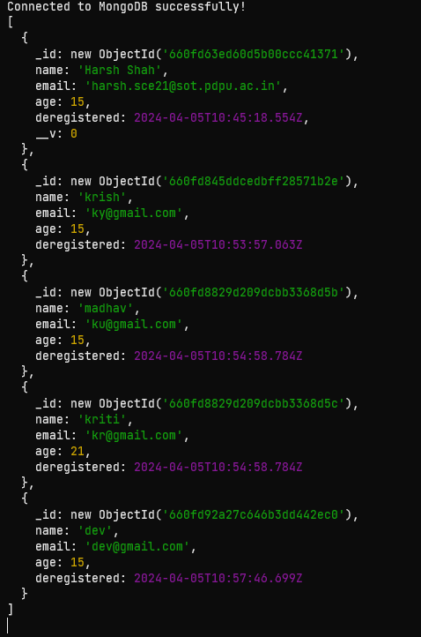

- Find with query
obj.find({ name: "dev" })
.then((doc) => {
console.log(doc);
})
.catch((err) => {
console.log(err);
});
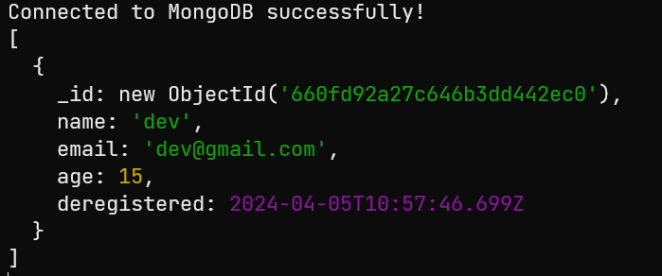

Delete Operation
- Delete One
obj.deleteOne({name: "kriti"})
.then((docs)=>{
if(docs) {
console.log(docs);
} else {
console.log("no such user exist");
}
}).catch((err)=>{
console.log(err);
});
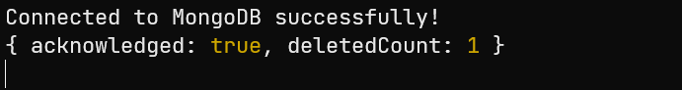
- Delete Many
obj.deleteMany({age: 21})
.then((docs)=>{
if(docs) {
console.log(docs);
} else {
console.log("no such user exist");
}
}).catch((err)=>{
console.log(err);
});
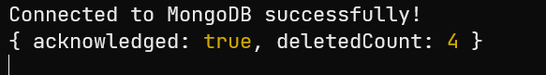

MongoDB Compass
